Nage No Kata
Nage No Kata is traditionally the first of two Randori No Kata used in Judo. Jigoro Kano(the founder of Judo), developed a number of kata from the jiu jitsu he had learnt as a youth, and this particular kata concentrates on a set of fifteen throws. Due to the historic links to Kodokan Judo, Shorinji Kan Jiu Jitsu includes nage no kata on its syllabus.
Unfortunately the kata has been open to dispute and personal interpretation over the years both within Judo and Jiu Jitsu. To this end it is difficult to precisely describe the ceremony, postures and actions.
The description of nage no kata presented here is based upon that set out by the Kodokan Committee who are responsible for Judo development across the world - and their description has been set out by several of Kano's original students and other senior judoka.

Beginning the Kata
To begin nage no kata, uki and tori should stand facing one another as shown in the diagram on the right. This position assumes that the uki and tori are in the dojo, but are entering onto the tatami specifcally to perform this kata. It will more often be the case that the uki and tori are already on the mat and that this position may be unnecessary. Once in position the two jitsuka will rei onto the mat (typically to the instructor). | 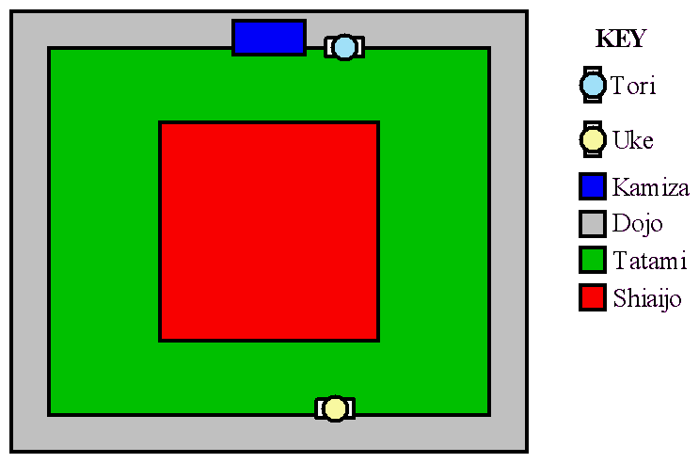

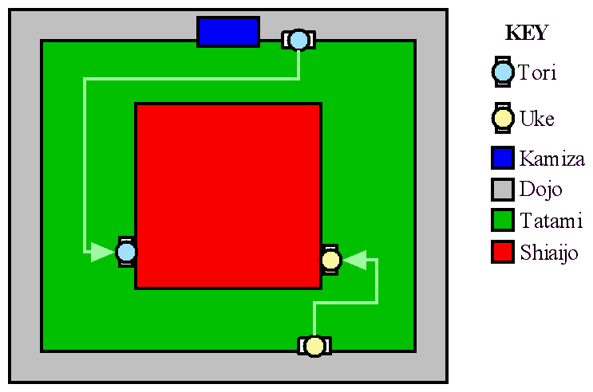 | Kata are normally demonstrated in a sectioned off area of the tatami called the Shiaijo. Shiai are competitions and this area is simply the area that would be set aside for opponents to fight within.  Once they have rei'ed onto the mat the jitsuka make their way to the edge of the shiaijo at a normal walking pace. Once both jitsuka have arrived at their positions, they should turn and bow (ritsurei) to the kamiza (which should be where the instructor is standing), and then after a moments pause turn and face one another.
Next both jitsuka kneel down into seiza and perform a kneeling bow (za rei) to one another. Both jitsuka then rise back up to their feet.
The shiaijo should be such that there is about eighteen feet between uke and tori - three full mat lengths. This should allow enough space to perform all of the necessary throws without either jitsuka having to leave the shiaijo.
Uke and tori now make their way towards the center shimoseki-joseki axis of the shiaijo following a smooth curve. At this point the jitsuka should begin to use ayumi ashi (walking with feet brushing the surface of the mat). Uke and tori should end up a little over a half a metre apart - a comfortable position for a traditional judo grip.  From this point on until the end of the kata the uki and tori should now step using tsugi ashi (walking with feet sliding across the surface of the mat). | 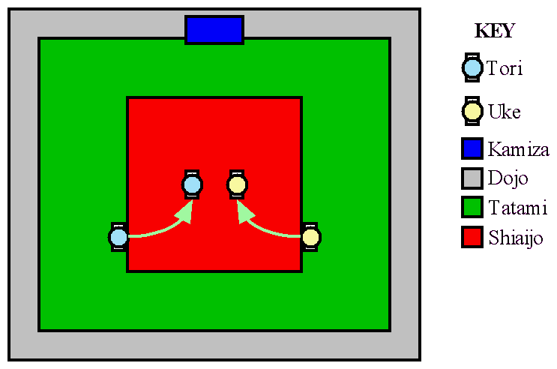
Often if asked to perform this in practise or perhaps even in a grading, both uke and tori will already be paired up. In such a case simply ensure that there is enough room to continue - ritsu rei to the instructor, then one another, and then begin.

Throwing Sets

Te Waza - Hand Techniques
- Uki Otoshi - floating drop
- Ippon Seio Nage - one arm shoulder throw
- Kata Guruma - shoulder wheel

Koshi Waza - Hip Techniques
- Uki Goshi - floating hip
- Harai Goshi - sweeping loin
- Tsuri Komi Goshi - lifting pulling hip

Ashi Waza - Ankle Techniques
- Okuri Ashi Barai - accompanying foot sweep
- Sasae Tsuri Komi Ashi - forward lifting pulling ankle
- Uchi Mata - inner thigh

Ma Sutemi Waza - Front Sacrifice Techniques
- Tomoe Nage - stomach throw
- Ura Nage - back throw
- Sumi Gaeshi - corner twist

Yoko Sutemi Waza - Side sacrifice Techniques
- Yoko Gake - side prop
- Yoko Guruma - side wheel
- Uki Waza - floating technique

Ending the Kata
To finish nage no kata, both uke and tori return to the edge of the shiaijo and repeat the same procedure as they did for entering into the kata, but this time in reverse.

