Maryland National Capital Park and Planning Commission
Department of Parks and Recreation
Prince Georges County-Northern Area
Beltsville Community Center
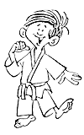
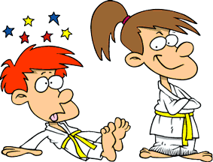
Hello, Beltsville Kids care
Judo is for you!
Come take a judo class
It is fun and exciting!!


The Beginners Judo program is a wonderful opportunity to be introduced into the art of judo. The program includes 8 weeks of instruction on the basic judo fundamentals and techniques. Students will learn Japanese terminology, the use of force, principles of maximum efficiency with minimum effort with mutual welfare and benefit. They will be instructed in basic holds, like the scarf hold and throwing techniques like the hip throw, shoulder throw and outer sweep. Students will learn how to apply the use of balance, momentum, skill and timing to perform the techniques.

There are two oppertunities to join beginners judo. One is on Tuesday evenings from 715 to 830 beginning on the first Tuesday of every other month, then running for 8 weeks.

The other class begins on March ? then runs each Sunday from 130 to 3 pm for eight week class. The entire course is offered for just $30. Please sign up at the desk.

Upon completion of the beginners course, students may continue instruction on Tuesday and Thursday with the judo club by taking advanced judo lessons. Advanced students participate in local tournaments earn many trophies, medals and other awards.

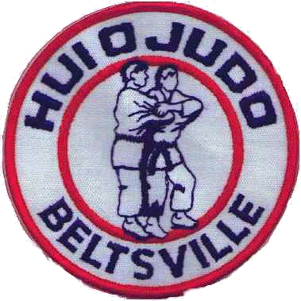
Beltsville Judo Club
Beltsville Community Center
3900 Sellman Road
Beltsville, Maryland 20705
(301) 937-6613

Instructors:
Kevin Tamai (Yodan)
Mark Smith (Sandan)
Brad Mason (Nidan)
Karen Whilden (Godan)
Chris Howell (Ikkyu)
Robert Kirk (Nikyu)

Member of United States Judo Federation
and United States Judo Inc.
For more information contact
Sensei Kevin Tamai at (703) 622-6861
Email at tamaik@juno.com

Sensei Mark Smith at 301-674-5438
or email at mark@huiojudo.com
Se habla espanol

Visit our website www.huiojudo.com

What is Judo?
Judo is many things to different people. It is a sport, an art, a discipline, a recreational or social activity, a fitness program, a means of self defense and a way of life. It is to some extent all of these, but to most participants, it is a sport.

Judo comes to us from the fighting systems of feudal Japan. Founded in 1882 by Jigoro Kano, Judo is a refinement of the ancient martial art of Jujitsu. Dr. Kano, President of the University of Education in Tokyo, made comprehensive studies of these ancient art forms and integrated the best of their techniques into what is now the modern sport of Judo.

Judo was introduced into the Olympic Games in 1964 and is now played by millions of people throughout the world. People study judo to excel in competition, to stay in shape, to develop self confidence, and for many other reasons. But most of all, people partake in judo just for the enjoyment and fun of it. Judo is a sport that is a lot of fun.

Judo can best be described as a special form of wrestling that emphasizes throws as well as pins. Judo is best known for it spectacular throwing techniques. The players wear special clothing to help with the application of the techniques. The clothing provides control for maximum safety in practice and in competitive play. Judo is performed on special mats for added safety and comfort.

Because judo is a contact sport, there is some risk for injury. However, judo has a much lower accident rate than most other sports. Judo has a very strict set of rules that govern competitive play and ensures the safety of all participants. There is competition at all skill levels, from club to international tournaments and up to the Olympic Games. There are separate divisions for males and females.

Unlike most other martial arts, there is no kicking or punching in judo. You do not have to wear any protective clothing or gear. Judo emphasizes sport, fun, safety, and full physical activity for top conditioning.

Judo is an inexpensive, year round activity that appeals to people from all walks of life. Judo provides the means for learning and improving oneself – physically, mentally, socially and spiritually.

Principles and goals of Judo

Judo, which is translated to “gentle way”, prescribes the principle of flexibility in the application of the techniques. This is the flexible or efficient use of balance, leverage and momentum in the performance of the techniques. Skill and timing are the essential ingredients for success in judo , rather than brute strength.

Dr. Kano felt that healthy social attitudes, as well as a sound mind and body, could be developed through the proper judo training. He stated this philosophy of Judo in the form of two maximums.

The first maxim, “Maximum efficiency,” means that whatever one does, it should be with the optimal use of one’s mental and physical energy. In judo, you learn how to make the most effective use of both body and mind. This ability

The second maxim, “mutual welfare and benefit,” simply means that we should be considerate of and helpful to others. In Judo, the students quickly learn cooperate and help each other to advance in their training. This is basically the idea of give and take. This concept of cooperation can all be applied in our association with others in life.

The final aim or goal of judo, as expressed by Dr. Kano, is self perfection or “the harmonious development and eventual perfection of human character.” Simply stated, the true goal of Judo is to make a person the best that they can be.”

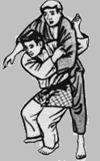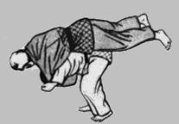
Judo training

Judo training can develop a competitive spirit and a feeling of confidence in a variety of situations. Judo develops self discipline and respect for one’s self and others.

Regular Judo training can improve an individual’s aerobic capacity, speed, power, strength, agility, and flexibility. As a sport that has evolved from a fighting art, it develops complete body control, fine balance, and a fast reflexive action. Above all, it develops a sharp reacting mind well coordinated with the same kind of body. Judo utilizes virtually every muscle of the body and is an excellent overall conditioner.

Judo is unique in that all age groups and both sexes can participate together in learning and playing the sport. Judo provides a lifetime recreational opportunity that can be practiced by any individual. Many people over sixty years of age enjoy the sport as well as children as young as four years old. For those who compete, Judo provides both a challenging and rewarding sport. For those not interested in competition, Judo provides for an enjoyable fitness or recreational activity that emphasizes fun with safety.

Judo training gives a person an effective self defense system if the need arises. While self defense is not normally emphasized in practice, Judo training does give one a decisive advantage over the untrained individual.

Finally, Judo training teaches a person how to fall safely without injury, which is a skill that is unique to Judo. This is a useful skill in everyday life.

