Nage no Kata

Forms of Throwing
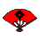
The Nage no Kata was developed in 1884 and 1885 at the Kodokan. This kata consists of 5 sets of three throws, each performed on both the left and right sides. The two participants formally bow onto the mat and begin the kata with the tori, or thrower, on your right and the uke, or person being thrown, on your left. In each case, the uke attempts an attack on tori. There is a progression of attack styles here, demonstrating how tori must adjust to these differing attacks. Uke then changes his attacks based on the previous adjustments made by tori.

Te Waza (Hand Techniques)

Uki Otoshi--Floating Drop
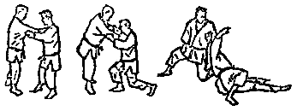Here uke, having no prior experience with tori, starts with a very agressive attack by grasping tori's jacket and pushing tori backward. Tori responds by stepping backward, demonstrating the principle of yielding and pulling uke forward culminating in the throw that you see. This throw exemplifies the beauty and dynamic precision of the forces which can unbalance an opponent and cause his body to trace a long arc in the air as he is snapped forward, off his feet, by the downward drawing power of the thrower's body transmitted through his arms.

Seoi Nage--Shoulder Throw
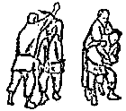Uke changes the attack here to an aggressive downward strike to the top of tori's head, which tori blocks, steps in and lowers his body to effectively use the momentum generated by the attack to throw the attacker over his back and shoulder. This throw is a modification of a jujutsu throw in which the arm is broken during the throw and clearly shows the self defense aspect inherent in the kata.

Kata Guruma--Shoulder Wheel
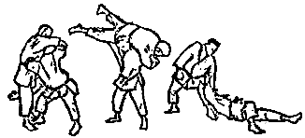Uke attacks as in the first throw, but holds back a bit and braces his front leg to prevent himself from being pulled down as in the first throw. To counter this action, tori takes a large step backward, stretching uke out and drops down and in to take advantage of the bent leg and lifts uke across his shoulders to throw him in a motion like a wheel.

Koshi Waza (Hip Techniques)

Uki Goshi--Floating Hip
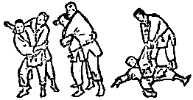Uke attempts to strike tori but keeps his other hand in front to block tori's hip so that he cannot turn into the shoulder throw as in the first set. Tori compensates by turning opposite to the first throw, coming in under the strike and grasping the outstretched arm of uke, bringing his hip into uke and turning to throw uke, while pulling on uke's arm and lifting uke with the arm on his back. This throw was the favorite throw of Jigoro Kano.

Harai Goshi--Sweeping Hip
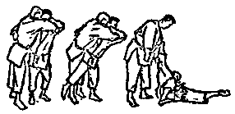Uke attempts to block the previous kinds of throws in this attack by softening his body. Tori, is able to float uke upward and forward to compensate for this in this sweeping hip throw, which is an adaptation of techniques from jujutsu and sumo.

Tsuri Komi Goshi--Lifting Pulling Hip
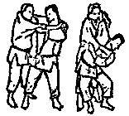Here uke, anticipating the previous throw, stiffens more dramatically to prevent the previous throw but tori, by taking a high grip on the collar and adjusting the stepping action, never lets uke get going. The sudden, unexpected lowering of tori's body enables uke to be thrown end over end, like a stick.

Ashi Waza (Foot Techniques)

Okuri Ashi Harai--Double Foot Sweep
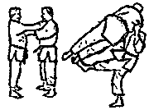Uke begins to attack but tori takes away the initiative by sliding to the side and pulling uke with him. Uke tries to catch up to avoid a throw over his leading side and as he passes tori, tori sweeps his legs out from the trailing side.

Sasae Tsuri Komi Ashi--Lifting Pulling Foot Block
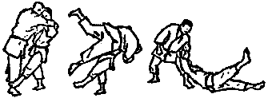Here as uke attacks, tori yields but changes his footwork on the third step by stepping to the side and turning. Using the force inherent in this action to offbalance uke, he is able to block uke's advancing foot and execute a large arcing forward throw.

Uchi Mata--Inner Thigh Throw
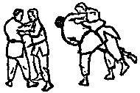Uke attempts to attack but again the initiative is taken away by tori who moves in a circular fashion, pulling uke around behind him. As uke is pulled in closer to tori's back, he is thrown just as he is about to place his advancing foot down by the sweeping action of tori leg upward against the inside of uke's thigh.

Ma Sutemi Waza (Rear Sacrifice Techniques)

Tomoe Nage--Stomach or Circle Throw
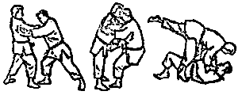Uke attacks by advancing his right foot. Tori yields a bit but then takes the inititative, unbalancing uke, by advancing his right foot forcing uke to step backward with his left foot. Tori continues advancing, pushing uke backward until uke pushes back. At this point, tori drops down onto his back, swinging his advanced foot up onto uke's hip and sliding his other foot under uke, between his legs. This action completely destroys uke's balance forcing him in a circular arc over tori's body.

Ura Nage--Back Throw
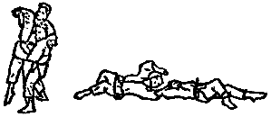Uke attempts to strike tori's head with a downward blow to the head. Tori steps in, under the blow, blends with ukes body, falling backward with uke's forward motion and culminating in a flat throw over his body.

Sumi Gaeshi--Corner Throw
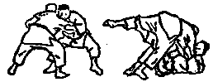Uke attacks with a modified defensive posture intent on pulling tori forward to unbalance him. Tori steals the initiative by also gripping in a modified defensive stance and pulling uke forward in one arc step. Uke resists by straighten up. Tori takes advantage of this by further floating uke upward and dropping straight down on his back and under uke. The lifting action of one of tori's feet combined with the momentum of uke's falling body, lifts uke in a high arc over tori's body.

Yoko Sutemi Waza (Side Sacrifice Techniques)

Yoko Gake--Side Hook
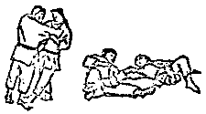Tori yields to uke's attack by stepping backward to preserve his balance and attempts to unbalance uke forward. Uke attempts to regain his balance by stepping forward again continuing his attack. Tori changes his horizontal pull to a inward and turning motion, causing uke to stiffen in order to resist this motion. As uke advances a third time, tori slides his foot into uke's advancing foot, cutting it out from under him and falling onto his side and pulling uke down with him.

Yoko Guruma--Side Wheel
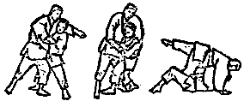Uke attempts to attack with a strike once again. Tori attempts the same back throw as before by ducking in under uke's arm. Uke counters this by using his striking arm to force tori's head down. Tori takes advantage of ukes reaction lauching a counter attack in the form of a wheeling action. He slides a leg between uke's legs, falls onto his side and slings the unbalanced uke in the direction of his bent body.

Uki Waza--Floating Throw
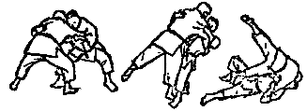Uke attacks in the modified defensive stance to pull tori forward. Tori again assumes the same posture, resists uke's attack and counterattacks by pulling uke forward with an arc step. Uke resists by straightening up and tori counters by floating uke even further, falling to his side, and drawing uke over his outstretched leg in a long arc, as uke attempts to regain his balance by stepping forward.

