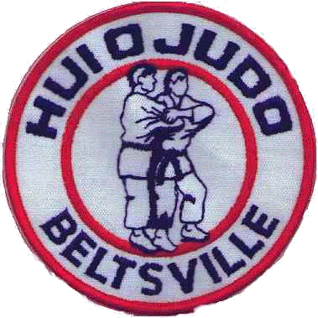Beginners Study sheet
Judo: “Gentle Way”
2 principles:
- Seiryoku zenyo: maximum efficiency
With minimum effort
- Jita kyoei: mutual welfare & benefit
Founder: Dr Jigoro Kano
Year: 1882
Mother school: Kodokan
Location: Tokyo Japan
Sensei: teacher
Dojo: place to practice Judo
Hidari: left Migi: right
Zempokaiten: forward rolling breakfall
Seiza: formal sitting position, kneeling
Ritsurei: standing bow
Zarei: kneeling bow
Shisei: posture
Shizenhontai: Basic fundamental natural posture
Jigohontai: Defensive posture
Ukemi: falling practice
Uchi komi: fitting in practice
Randori: free fighting
Parts of judo gi
Uwagi: jacket
Shitagi: pants
Obi: belt
Zori: slippers
Parts of throw
Kuzushi: off balancing the opponent
Tsukuri: fitting into the throw
Kake: Completing the throw
Contest terms:
Hajime: start
Matte: stop
Oasekomi: hold down time begin
Toketa: hold is broken
Sonomama: freeze
Yoshi: continue (after freeze)
Sodemade: stop end of contest
Ippon: full point
Wazari: half point
Yuko: advantage- less than wazari
Koka: advantage –less than Yuko
Shido: small penalty
Hansokumake: big penalty – DQ

Numbers  Ichi: 1  Ni: 2  San: 3  Shi: 4  Go: 5  Roku: 6  Shichi: 7  Hachi: 8  Ku: 9  Ju: 10 | Junior Ranks  Rokyu: white (6th kyu)  Gokyu: yellow (5th kyu)  Yonkyu: orange (4th kyu)  Sankyu: green (3rd kyu)  Nikyu: blue (2nd kyu)  Ikkyu: purple (1st kyu)

Kesa Gatame: Basic scarf hold
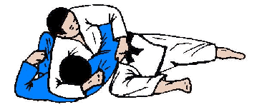
Yoko Shiho Gatame: Side 4-corner hold
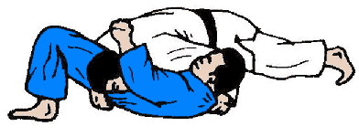
Kami Shiho Gatame: Upper 4-corner hold
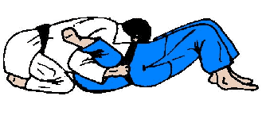
Tate Shiho Gatame: Lower 4-corner hold
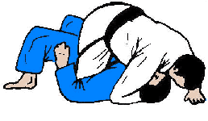
O Goshi: Major hip throw
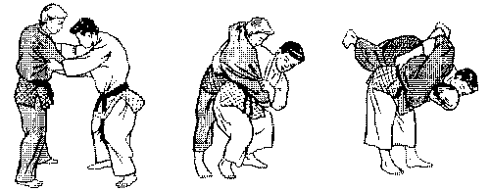
O Soto Gari: Major outer reap
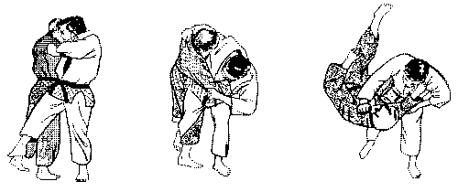
Ippon Seoi Nage: one armed shoulder throw
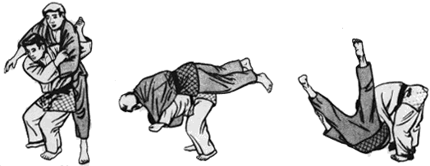

Tai Otoshi: Body drop
