Shisei Forms of Posture

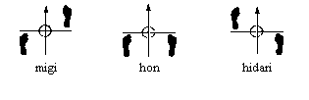
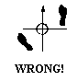

Keep both feet on the “railroad tracks” aimed along the rails.
Don’t let the back foot turn.

Shizentai . . . . . . . . . . . . . . . . . . . . . . . . . . . . . . . . . . natural stance
Migi Shizentai right natural stance
Shizenhontaoi basic natural stance
Hidari Shizentai left natural Stance
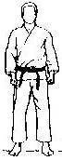

Jigotai . . . . . . . . . . . . . . . . . . . . . . . . . . . . . . . . . . . defensive stance
Migi Jigotai right defensive stance
Jigohontai basic defensive stance
Hidari Jigotai left defensive stance
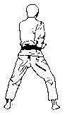

Shintai Forms of Movement

- Again keep those feet on the railroad track rails!
- Slide the feet instead of lifting (don’t stomp).
- Don’t let the toes pop up.
- Principals hold true for both forwards (ma) and backwards (ushiro)

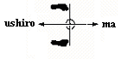

Ayumi Ashi . . . . . . . . . . . . . . . . . . . . . . . . . . . . . . . . . natural walking
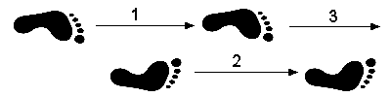

Tsugi Ashi. . . . . . . . . . . . . . . . . . . . . . . . . . . . . . . . . . Follow Foot Walking
Migi Tsugi Ashi . . . . . . . . . . . . . . . . . . . . . . . .right follow foot
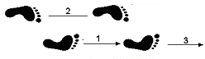

Hidari Tsugi Ashi. . . . . . . . . . . . . . . . . . . . . . . .left follow foot
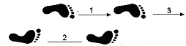

Tai Zabaki Forms of Body Turning

90 degree turn to right forward 90 degree turn to right rearward
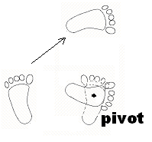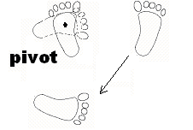

90 degree turn to left forward 90 degree turn to left forward
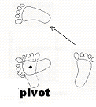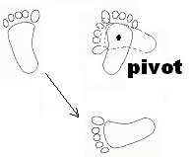
180 degree turn in one movement 180 degree turn in two movements
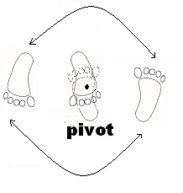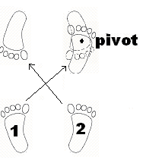
90 degree turn to right horseshoe 90 degree turn to left horseshoe
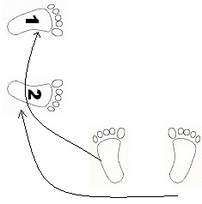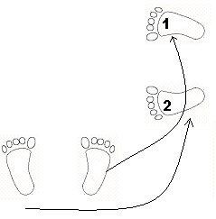
Kumikata Forms of Gripping

Shizentai Kumikata . . . . . . . . . . . . . . . . . . . . . . . . .grab from normal stance
Eri Dori lapel/collar grab
Sode Dori sleve grab
Shizentai natural stance
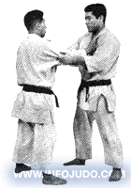

Jigotai Kumikata . . . . . . . . . . . . . . . . . . . . . . . . . . . grab from defensive stance
Kata Dori shoulder-blade grab
Hiji Dori elbow grab
Jigotai defensive stance
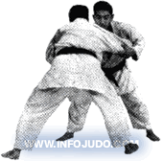
Happo no Kuzushi Eight Directions of Change

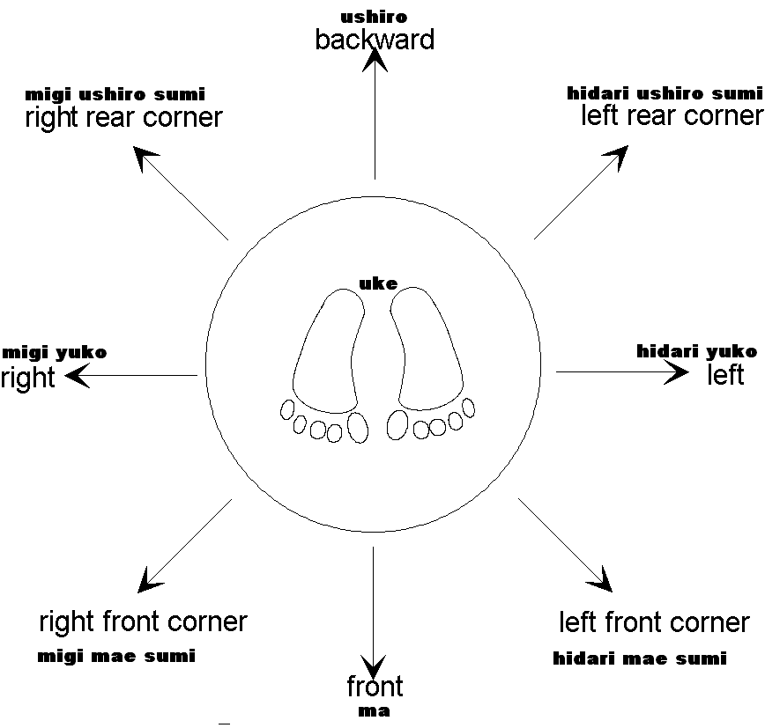

some texts also add:
- radial left
- radial right

since this concept of happo no kuzushi also exceeds the history of judo, the name will not change when more than 8 directions are described.
Judo Tatami Judo Mat

For shiai purposes, the judo mat is layed out identically for every match at every tournament.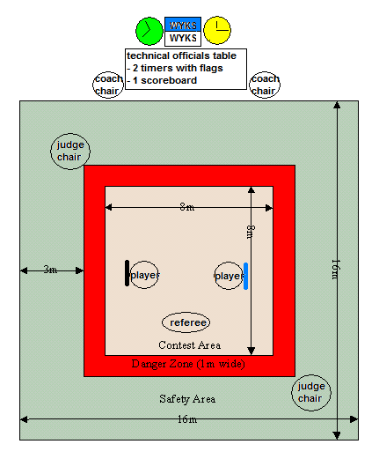
Players are awarded a penalty of shido for stepping out of bounds, or for standing too long (5 secs) in the danger zone without attacking.
Go Kyo No Waza 5 Stages of Technique

Dai I Kyo 1st Stage
De ashi Harai Advanced foot sweep Jr4, Sr5
Hiza-Guruma Knee Wheel Jr3, Sr5
Sasae Tsurikomi Ashi Propping Drawing Ankle throw Jr3, Sr5
Uki-goshi Floating hip throw Jr3, Sr5
O-soto-gari Major outer reap Jr5, Sr5
O-Goshi Major Hip Jr5, Sr5
O-uchi gari Major inner reap Jr4, Sr5
Seoi Nage Shoulder throw Jr5, Sr5
Dai Ni Kyo 2nd Stage
Ko-soto-gari Minor outer reap Jr1, Sr4
Ko-uchi-gari Minor inner reap Jr2, Sr4
Koshi-guruma Hip wheel Jr2, Sr4
Tsurikomi-goshi Lifting pulling hip throw Jr1, Sr4
Okuri ashi barai Sliding foot sweep Jr1, Sr4
Tai otoshi Body Drop Jr2, Sr4
Harai goshi Sweeping hip Sr4
Uchi mata Inner thigh Sr4
Dai San Kyo 3rd Stage
Ko-soto-gake Minor outer hook Sr3
Tsuri-goshi Pulling hip Sr3
Yoko otoshi Side drop Sr3
Ashi guruma Leg wheel Sr3
Hane-goshi Spring hip Sr3
Harai tsurikomi ashi Sweeping lift-pull foot Sr3
Tomoe nage Circular throw Sr3
Kata-guruma Shoulder wheel Sr3
Dai Yon Kyo 4th Stage
Sumi-gaeshi Corner counter Sr2
Tani-otoshi Valley drop Sr2
Hane-makikomi Spring wrapping throw Sr2
Sukuinage Scooping throw Sr2
Utsuri-goshi Hip shift Sr2
O-guruma Major wheel Sr2
Soto makikomi Outer wrapping throw Sr2
Uki otoshi Floating drop Sr2
Dai Go Kyo 5th Stage
O-soto guruma Major outer wheel Sr1
Uki waza Floating throw Sr1
Yoko wakare Side separation Sr1
Yoko guruma Side wheel Sr1
Ushiro goshi Back hip Sr1
Ura-nage Back throw Sr1
Sumi otoshi Corner drop Sr1
Yoko gake Side body drop hook Sr1
Newaza matwork techniques
Osaekomi waza pinning techniques
Kesa gatame scarf hold
… hon kesa gatame …. basic or fundamental Jr5,Sr5
Kuzure kesa gatame modified scarf hold
… makura kesa … pillow Jr2
… ushiro kesa … reverse Jr2
… kuzure kesa … modified Sr4
Yoko shiho gatame side 4-quarter hold Jr5,Sr5
Kami shiho gatame upper 4-quarter hold Jr4,Sr5
Kuzure kami shiho gatame modified upper 4-quarter hold Jr4,Sr4
Tate shiho gatame upright 4-quarter hold Jr3,Sr3
Kuzure tate shiho gatame modified upright 4-quarter hold Sr3
Kata gatame shoulder hold Jr3,Sr5
Sankaku gatame triangle hold Jr1

Shime waza (mae + ushiro) choking or strangulation techniques (front & rear)
Nami juji jime (m) normal cross choke Jr2
Kata juji jime (m) half cross choke Jr2
Gyaku juji jime (m) reverse cross choke
Ryote jime (m + u) both hand choke Jr1
Tsukomi jime (m) poking choke Jr1
Sankaku jime (m + u) triangle choke
Kata te jime (m + u) shoulder hand choke
Sode guruma jime (m + u) sleeve wheel choke
Kata ha jime (u) single wing choke Jr1
Eri jime lapel choke Jr1
Okuri eri jime (u) sliding lapel choke Jr2
Hadaka jime (u) naked choke Jr2
Jigoku jime hell strangle (a combination chocke & double arm lock)

Sr5 1m + 1u
Sr4 2m + 2u
Sr3 3m + 3u
Sr2 4m + 4u
Sr1 5m + 5u

Kansetsu waza (tachi + ne) joint (lock) techniques (standing & matwork)
Ude garami entangled arm
Ude hishigi ude gatame arm crushing arm hold
Ude hishigi juji gatame arm crushing cross hold
Ude hishigi ashi gatame arm crushing foot hold
Ude hishigi hiza gatame arm crushing knee hold
Ude hishigi hara gatame arm crushing stomach hold
Ude hishigi waki gatame arm crushing armpit hold
Ude hishigi sankaku gatame arm crushing triangle hold
Ude hishigi te gatame arm crushing hand hold
Ashi garami entangled foot (prohibited in shiai)
Ude hishigi kanuki gatami arm crushing gate latch-bolt hold (dropped from kdk)

Sr5 1
Sr4 2
Sr3 3
Sr2 4
Sr1 5

